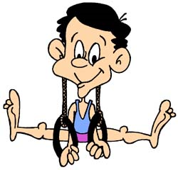
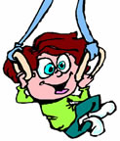
Jan 24-28: Monday to Friday
Jan 31-Feb 3: Monday to Thursday
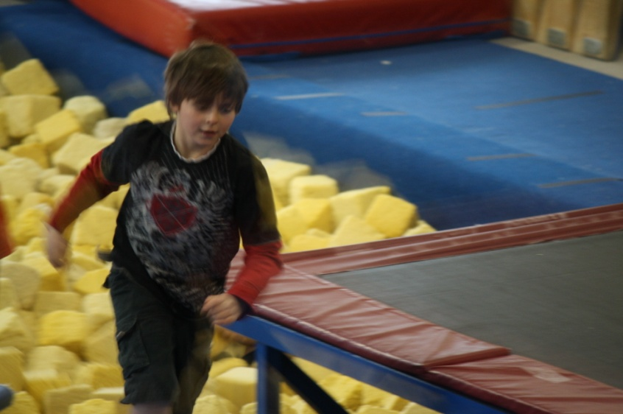

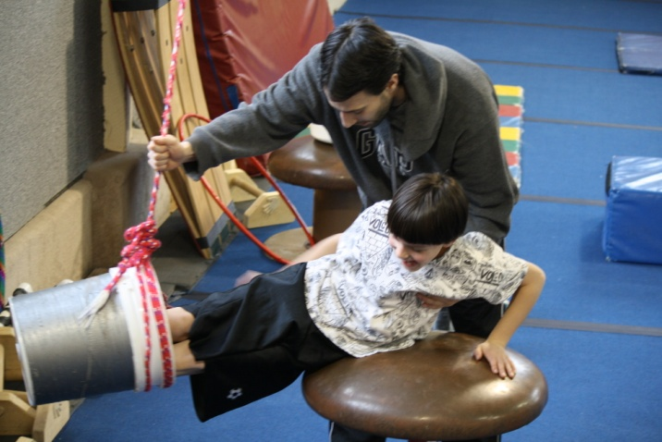
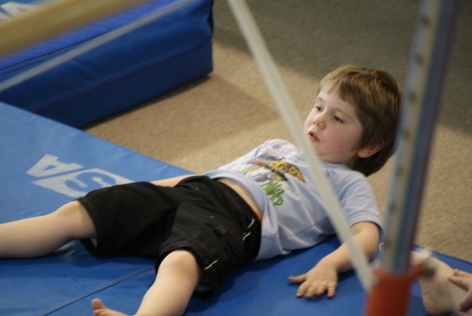
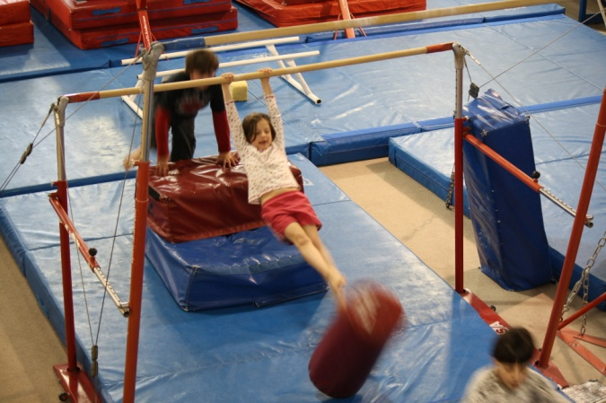
Needed !
Your paper towel rolls and margarine tubs with lids.
Many Thanks to...

Saturna Island Parks and Recreation for providing funds to pay for the students at our school to have swimming and gymnastics lessons!
What an tremendous Field Trip this week. We took in the Royal BC Museum where we explored the First Nations Gallery. It was positively fascinating. We learned a great deal about our First Nations peoples and how they lived.

The highlight of our trip was a visit to the Victoria Gymnastics Facility. The instructors took our kids through an exciting journey of gymnastic moves and exercises. There was the Tumble Walk where they discovered different ways of bouncing all the way down a long trampoline like structure that ended in the biggest foam pool we’ve ever seen. Then, on to the parallel bars where they each got to knock over a foam pillar. Next came something called “ Grand-father’s Feather Bed”. It is the biggest, fattest foam “Bed” you can imagine. The children looked like tiny ants next to it. This Tuesday its Bowling again and on the Gymnastics. The children are loving it and so are we.
What fun!!
Upcoming Dates

Jan. 25th: Field Trip to Victoria – Bowling and Gymnastics
Jan. 26th: Earthquake Drill
Feb. 16th: PAC Meeting
Mar. 1st: Field Trip to Dominion Astrophysical Observatory
Mar. 11-27th: Spring Break

